e-Services SingPass login | 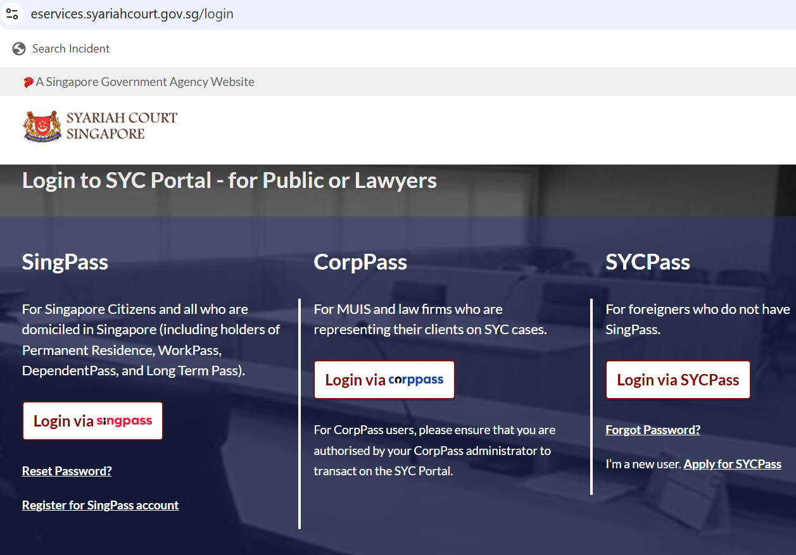
MOP divorce initialization after MCP complete | 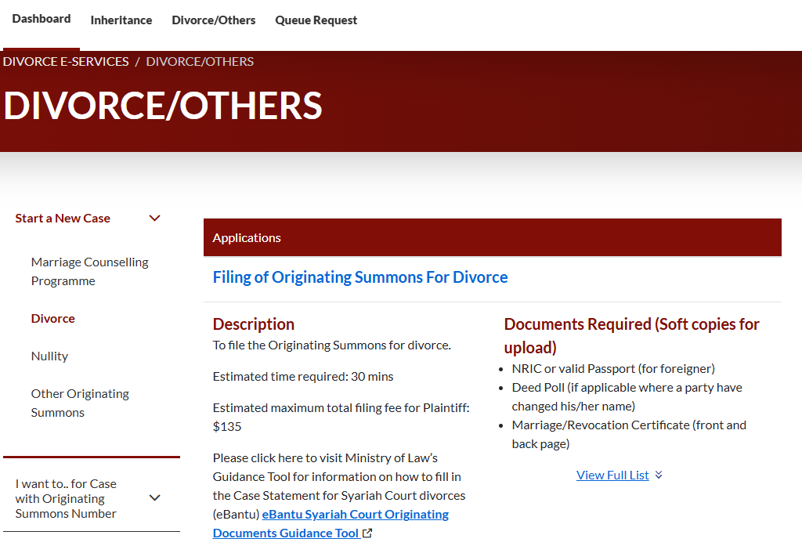
MOP will provide case ID and pre-OS Issuance date to validate and then matrimonial and parenting details | 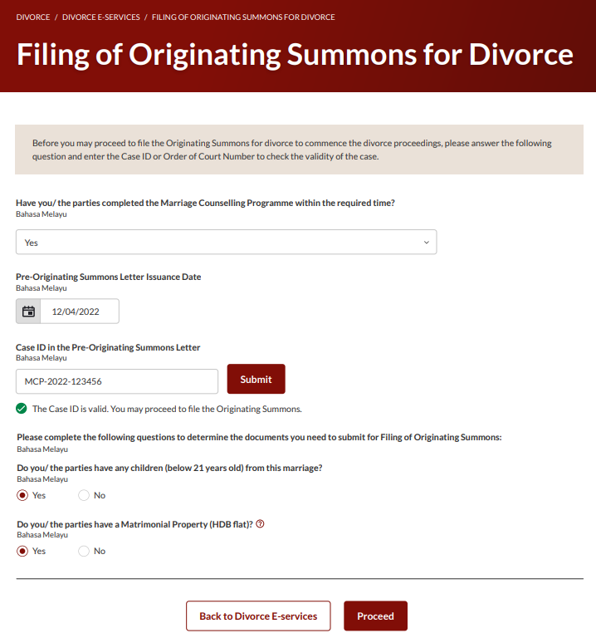
On click proceed redirect to screen. MOP can select e-Services and continue filing or new LIP model to file the Originating Summons | 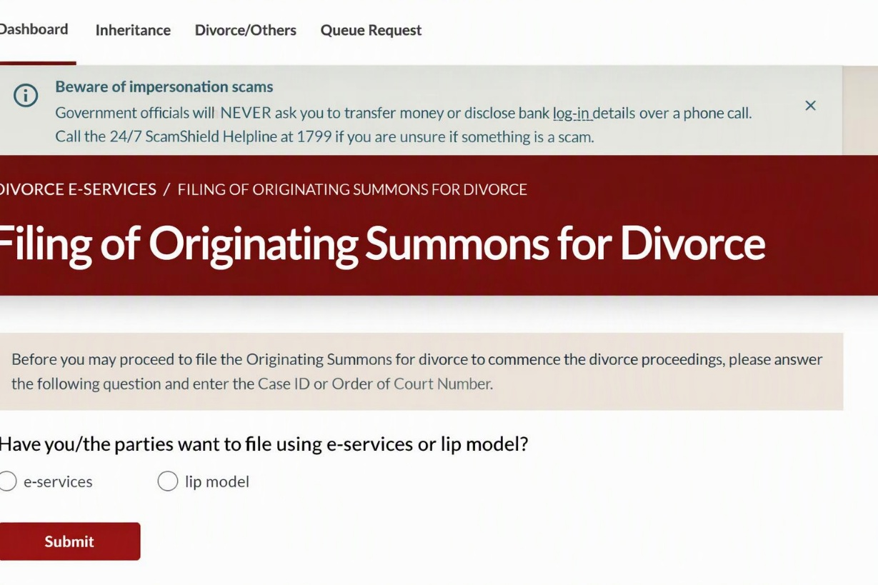
If MOP select e-Services | 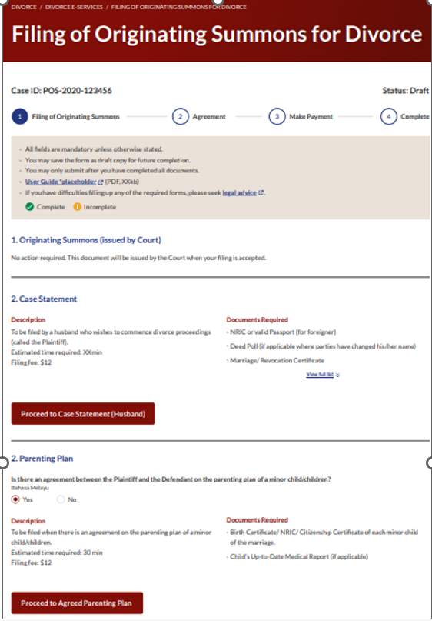
If MOP selected LIP Model. System will redirect to AI form | 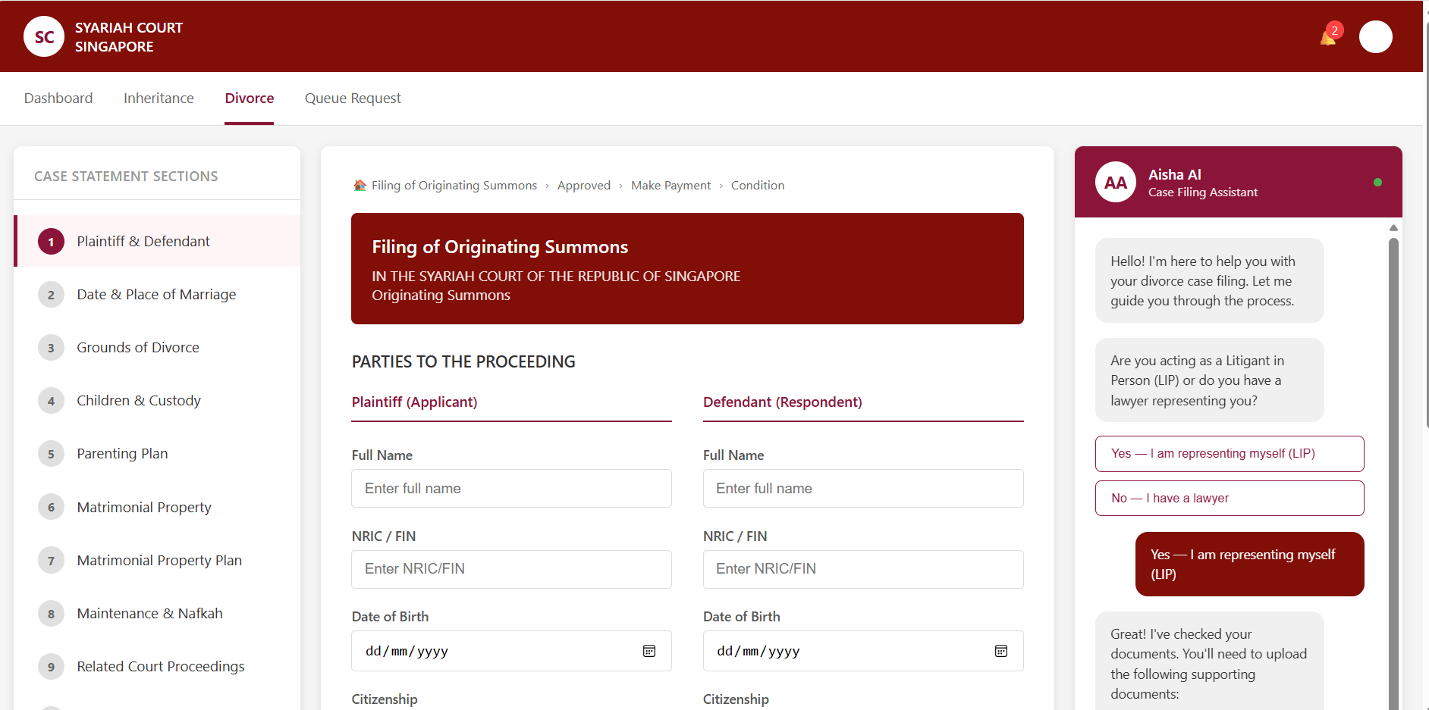
LIP Model with parenting plan and matrimonial plan details  Parenting plan may be proposed or agreed depending on the MOP selection.  Matrimonial plan may be proposed or agreed | 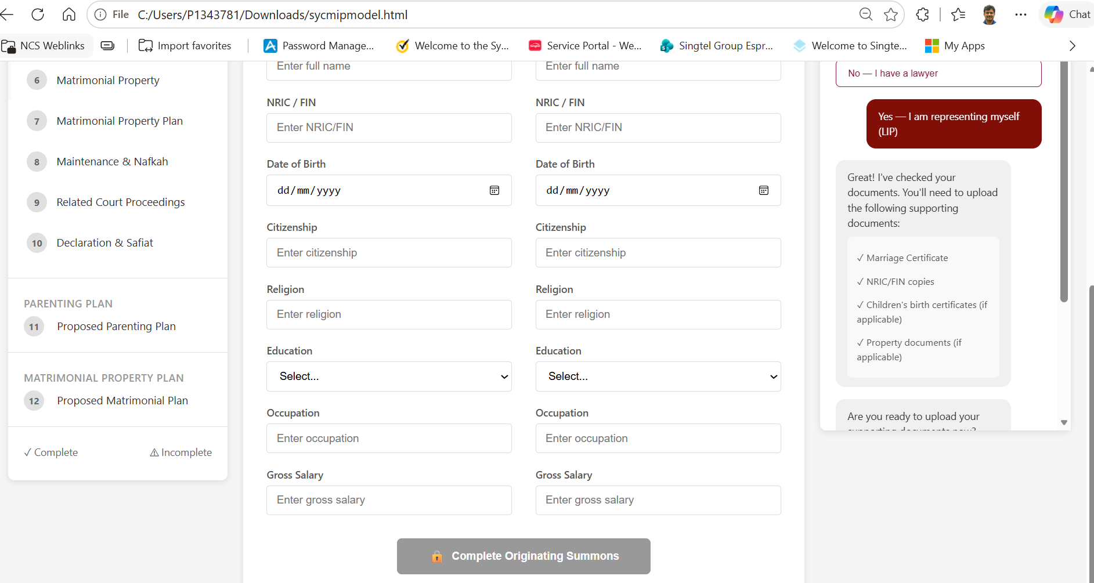
AI will do the validation on the details mismatch (e.g. Applicant Name mismatch, marriage date inconsistent. | 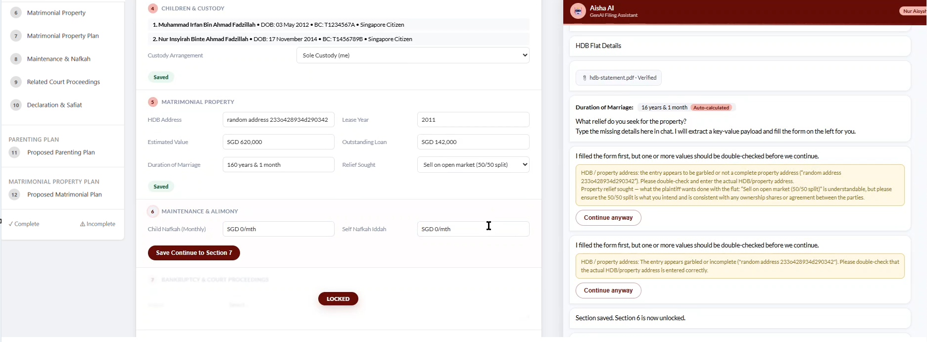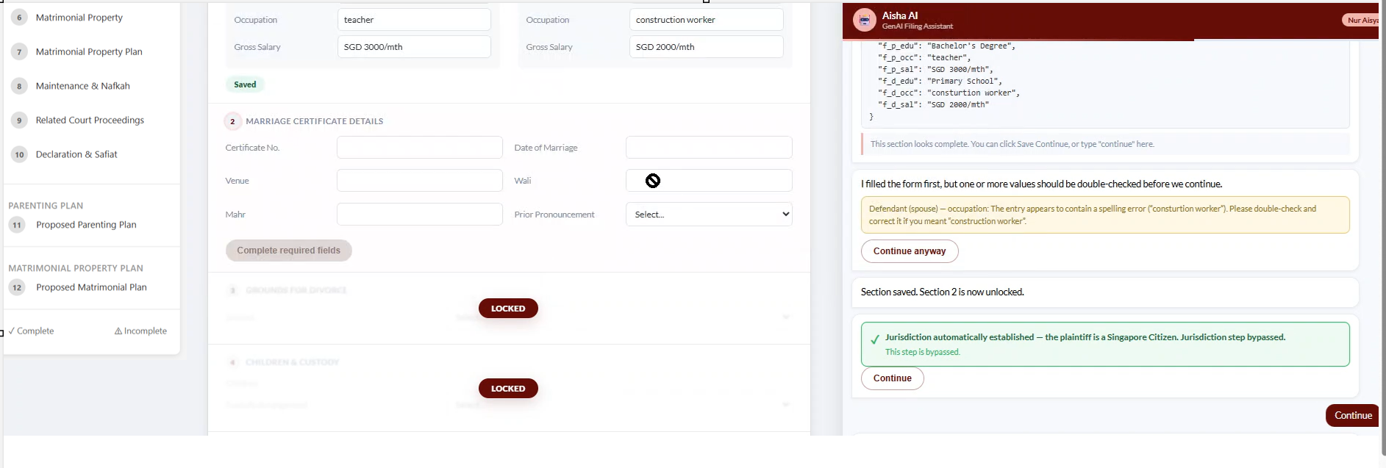
On complete system will take to agreement and then payment. | 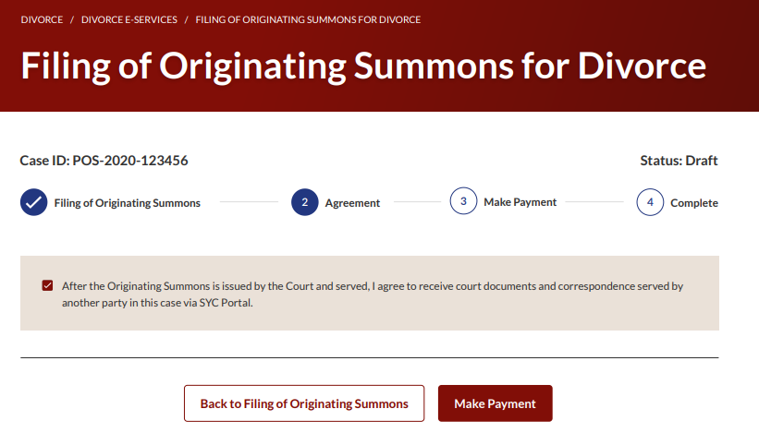
 | 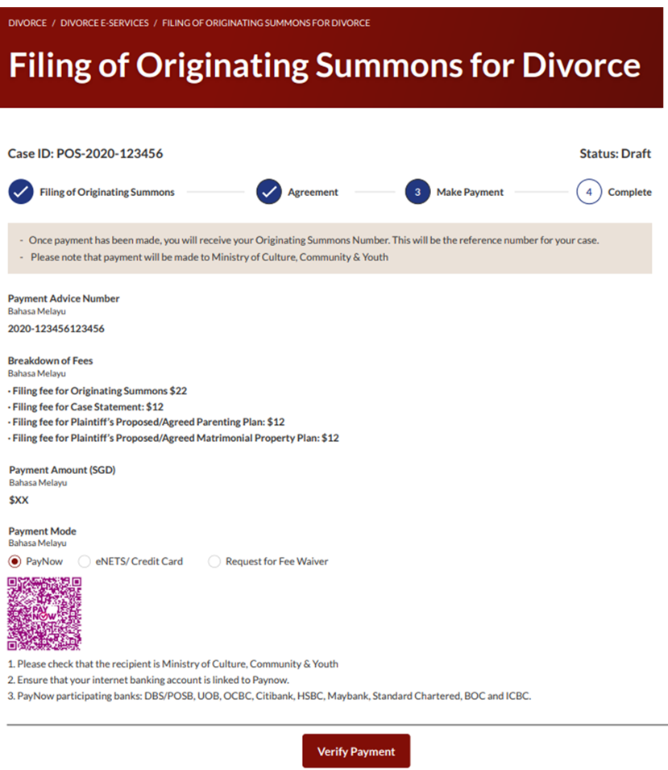
MOP can partially complete the application and via dashboard can visit the application and complete where he left | 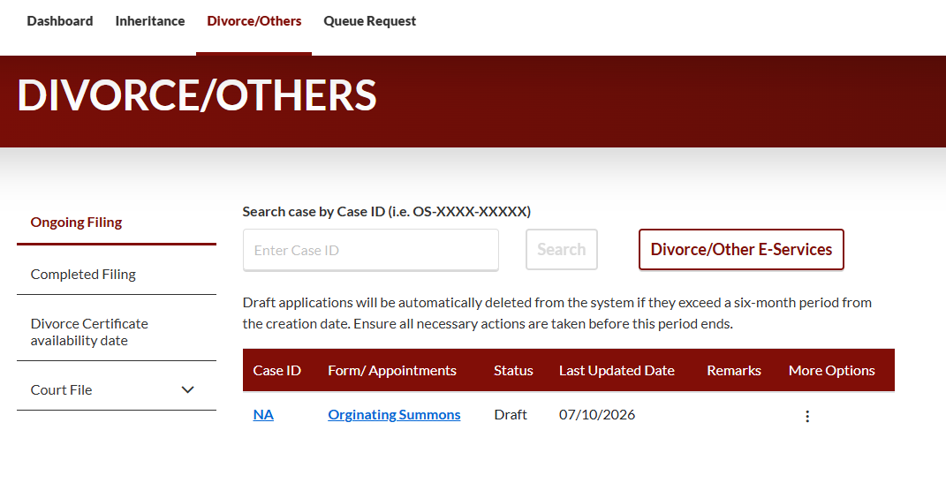
On click on the OS link
System takes to the AI form if MOP Opted LIP model

Divorce couple attend MCP session within 6 months to OS File Date with “abuse in the note for ground to divorce”
First scenario to  include the MCP session completed date and MCP generated number in AI.  AI must check filing with 6-month duration if not should not allow to submit.  AI must pull the existing MCP details and display them before proceeding | 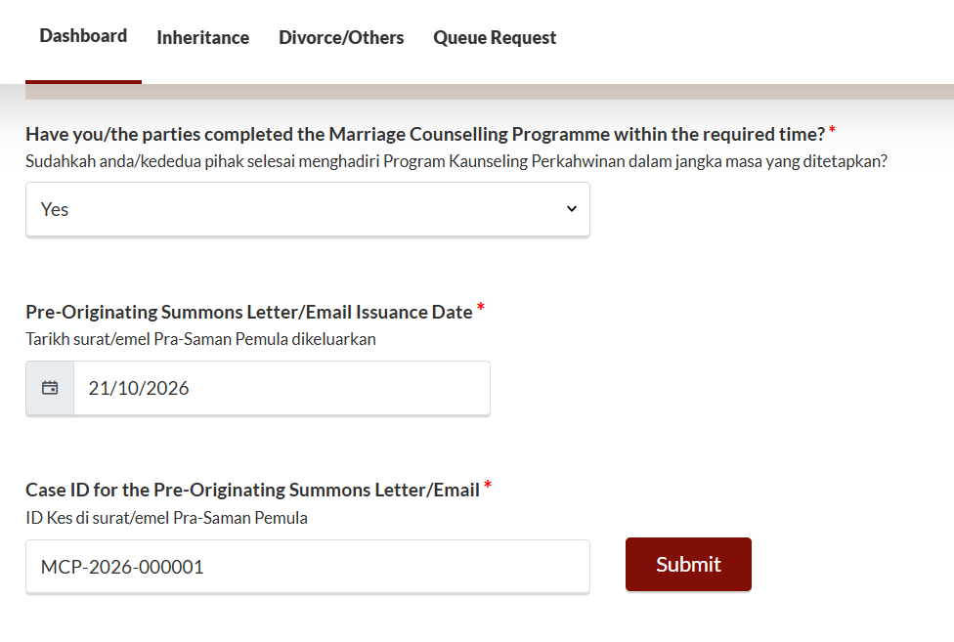
During the MCP, registrant will provide the reason for the application.  AI must pull the reason for the application display before proceeding | 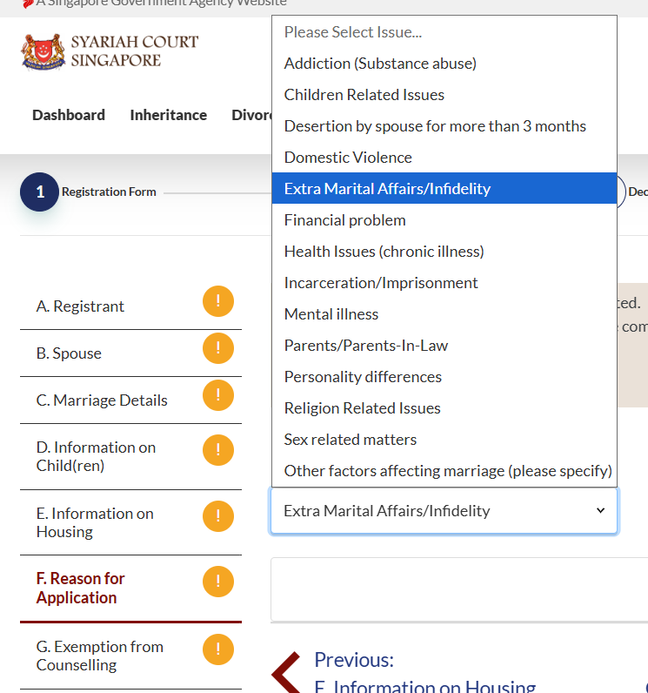

Divorce couple with 2 kids where only one belongs to this marriage
(Declared one in MCP but both in OS filing under children section but relief claim only for 1 with parenting plan mentioned both children)
In this scenario, the registrant declared one child during MCP registration.  However, the OS filing indicates two children, and the uploaded Parenting Plan also refers to two children. | 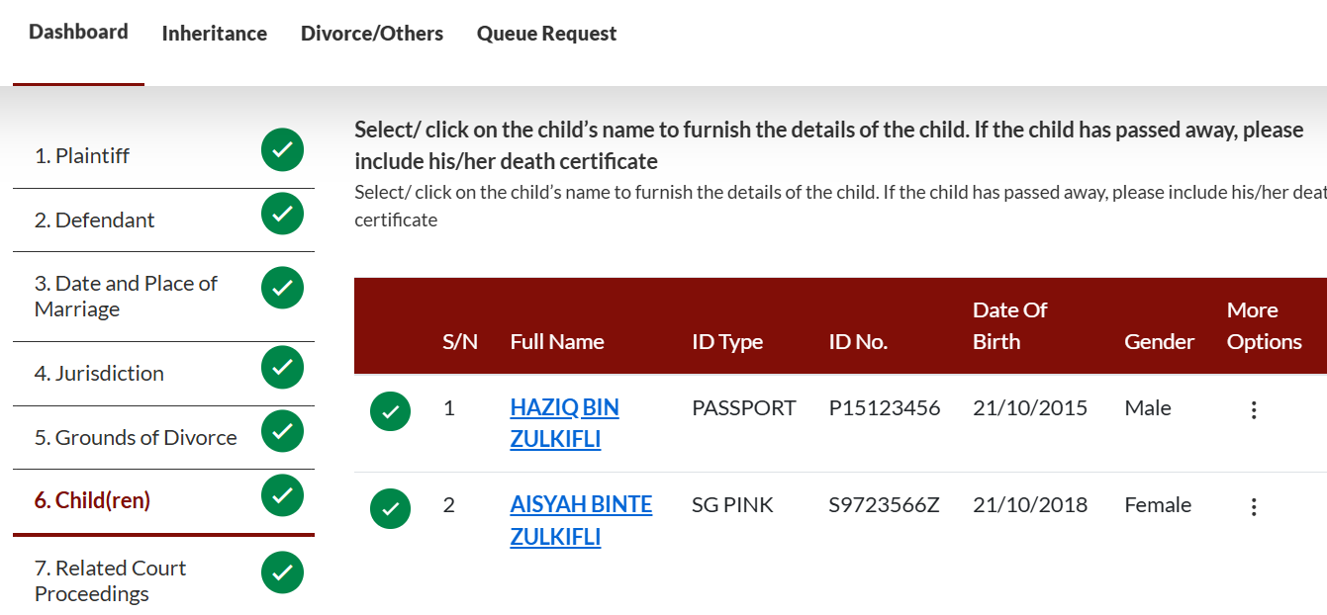
Custody, care and control | 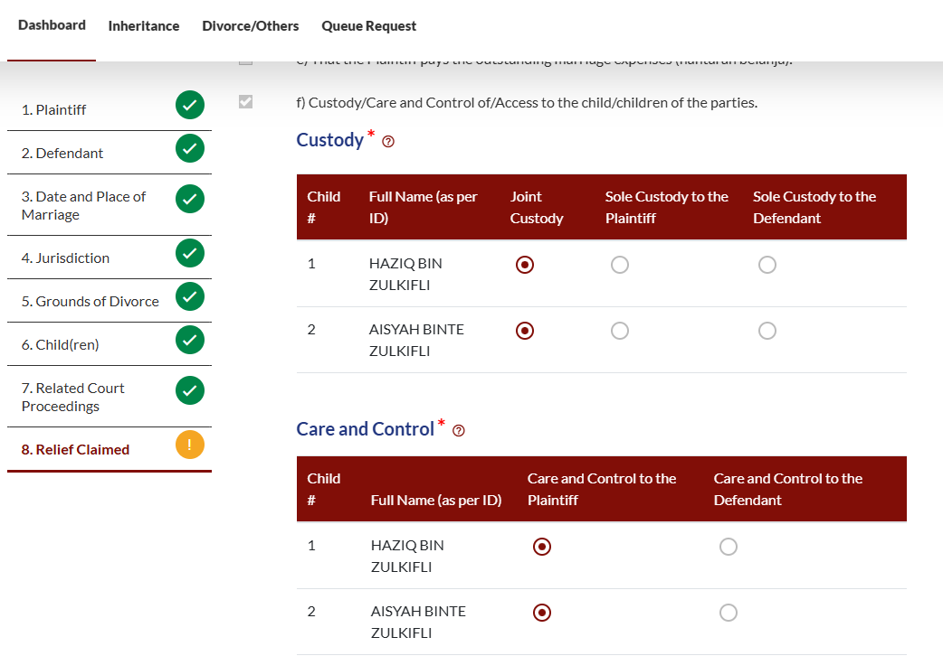
Parenting plan | Update the provided parenting plan document  Children and custody and parenting plan should be single section.  In the case, during MCP only one kid included  AI should prompt the below message and highlight the discrepancy  “Discrepancies between MCP and OS  Parenting plan does not match with relief claim  Highlight the discrepancy and ask them to confirm whether the children of this marriage have been correctly included”

Divorce couple with HDB. Property Plan handwritten indicate the wrong address as compared to the OS Case statement and in HDB.
In this scenario, AI should scan the matrimonial upload document and find the handwritten address and compare with my-info HDB address. | after the document upload system

Divorce couple with HDB. All tally – MCP, OS property section, HDB, CPF and property plan.

